Ashford Hill & Headley Fete
FUN DOG SHOW
With CHAMPIONSHIP kindly sponsored by
Sally Mathews Wessex Chiropractic
www.wessexchiropractic.co.uk
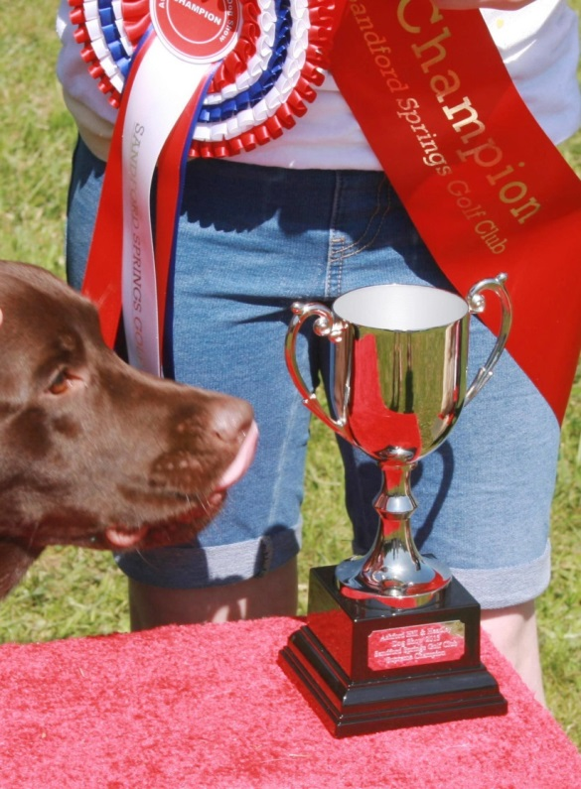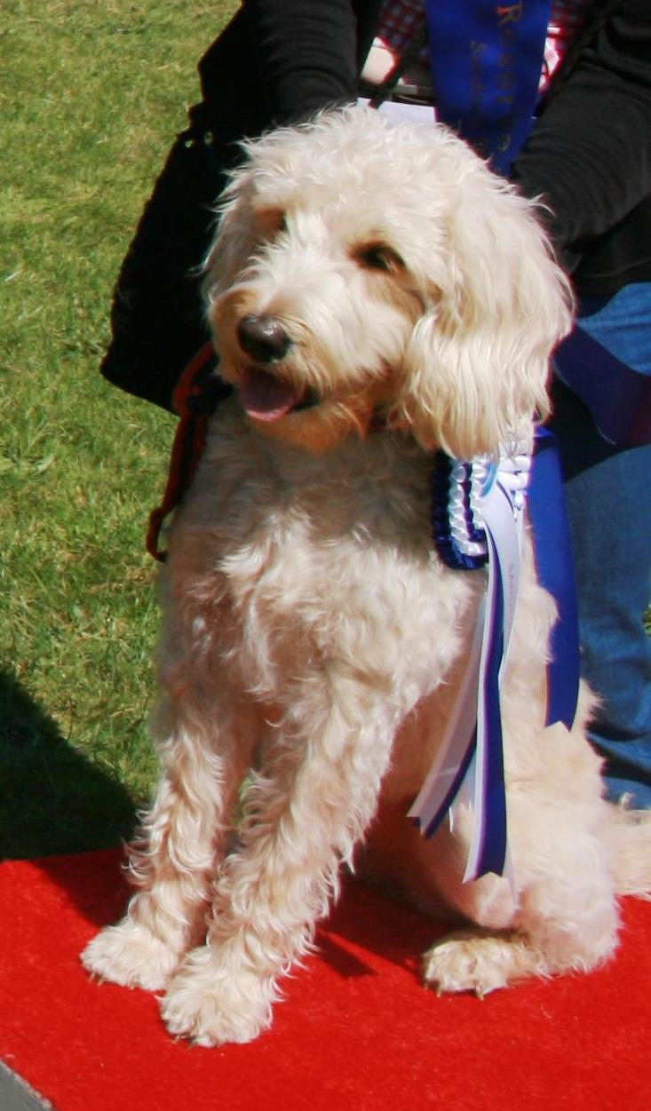
Saturday 6th June 2015
1PM Prompt (entries from Midday)
Headley Common, off A339 / Ashford Hill Road www.ashfordhillandheadleyfete.weebly.com
CLASSES

Class 1 Handsome Dog
Kindly sponsored by: HEADLEY WITH ASHFORD HILL COMMUNITY SHOP AND POST OFFICE www.headleyshop.org.uk

Class 2 Prettiest Bitch
Kindly Sponsored by: HEADLEY WITH ASHFORD HILL COMMUNITY SHOP AND POST OFFICE www.headleyshop.org.uk

Class 3 Rescue Dog
Kindly Sponsored by: HEADLEY WITH ASHFORD HILL COMMUNITY SHOP AND POST OFFICE www.headleyshop.org.uk
Open to dogs who have found a home through a dog rescue centre / charity.

Class 4 Golden Oldie – 7 years and above
Kindly sponsored by: SPLASH CANINE HYDROTHERAPY
Debbie Poynter, Baughurst, Hampshire, Telephone 01256 889585
www.splash4dogs.co.uk
Class 5 Junior Handler Kindly sponsored by: BERKSHIRE DOG TRAINING
Jules Clapham 07769 731232. Jules is based in Ashford Hill
To be shown by child 7 - 16 years. Will be judged on ability of child handler, and obedience and temperament of the dog.

Class 6 Family Dog Kindly sponsored by: BERKSHIRE DOG TRAINING
Jules Clapham 07769 731232. Jules is based in Ashford Hill
Judged on temperament and suitability as a pet for all members of the family.

Class 7 Gun Dog
Kindly Sponsored by: HEADLEY WITH ASHFORD HILL COMMUNITY SHOP AND POST OFFICE www.headleyshop.org.uk
Open to all types of Pointers, Retrievers, Setters, Flushing Dogs and Water Dogs. This class will be judged on confirmation and condition, and there will be no requirement to demonstrate any capability as a gun dog.

SUPREME CHAMPIONSHIP (3PM APPROX)
Kindly sponsored by:
Sally Mathews Wessex Chiropractic www.wessexchiropractic.co.uk
After the final class we will invite all 1st and 2nd Placed dogs back into the ring to compete for the Supreme Championship and Supreme Reserve Championship.

RULES & CONDITIONS OF ENTRY

Splash Canine Hydrotherapy & Training Centre
Debbie Poynter, Baughurst, Hampshire
Telephone 01256 889585
www.splash4dogs.co.uk
WESSEX CHIROPRACTIC

"Wessex Chiropractic treats both people and animals. Chiropractic treatment of animals is becoming increasingly popular in the UK. It is a complementary healthcare treatment used alongside traditional veterinary care. Our dogs and horses may perform for us at the highest levels or be a much-loved family pet. Regardless, the stresses and strains of daily life take their toll and some animals, just like humans, suffer from injuries."
Sally Mathews Wessex Chiropractic
www.wessexchiropractic.co.uk
Based in Basingstoke

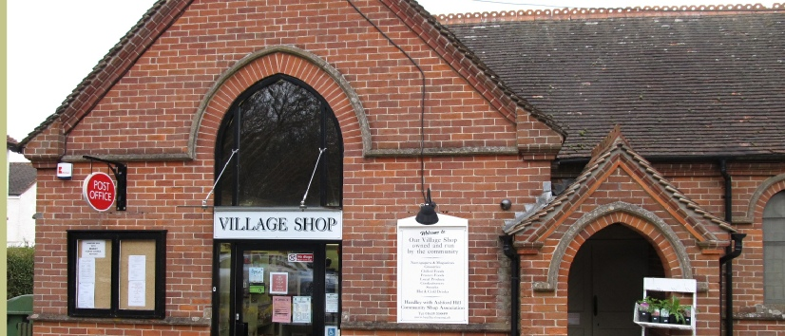
HEADLEY WITH ASHFORD HILL COMMUNITY SHOP AND POST OFFICE
www.headleyshop.org.uk Tel: 01635 268849 Email: headleyshop@hotmail.co.uk

The Baptist Church, Thornford Road, Headley, Berkshire, RG19 8AD

Shop: Mon - Fri: 5.30am - 5.30pm Sat: 6.30am - 12.30pm Sun: 6.30am - 9.00am
Post Office: Mon, Tue, Thu, Fri: 9.00am - 1.00pm 2.00pm - 5.00pm
Wed: 9.00am - 1.00pm (closed pm) Sat: 9.00am - 12 noon

BERKSHIRE DOG TRAINING
We offer agility classes for all levels, fun/pet classes right through to competition level at our indoor venue in Headley. We also provide Kennel Club Good Citizen classes, puppy foundation to Gold level in Headley village hall.
Agility training days, guest trainers and general canine day courses such as first aid are held on a regular basis.
Jules Clapham
www.berkshiredogtraining.co.uk / info@berkshiredogtraining.co.uk
07769731232
www.jjggees.co.uk / info@jjggees.co.uk

RULES & CONDITIONS OF ENTRY

1. No Claims will be entertained for anything that may happen to Competitors, their servants, onlookers, dogs, vehicles or property in connection with, or arising from, this event and it shall be a condition of entry that each entrant shall indemnify the Committee and against any legal action arising from any mishap.

2. The Judge’s decision is final in all events.

3. The Committee reserve the right to refuse or reject any entry and to amend or cancel any class at their discretion.

4. Any complaints must be written out and handed to the Dog Show Secretary within 30 minutes of the incident, accompanied by a fee of £20, which will be refunded if the complaint is upheld.

5. All attendees are reminded that rudeness or bad behaviour will not be tolerated, the person or persons may be asked to leave the venue.

6. NUMBERS MUST BE WORN AROUND YOUR WAIST TO IDENTIFY YOU IN THE SHOW RING. PLEASE COLLECT THEM FROM THE SHOW SECRETARY.

7. ALL DOG LITTER MUST BE REMOVED.

8. Dogs to be kept on a lead at all times.

9. No dogs under 20 weeks old in ANY class.

10. Dogs behaving dangerously out of control will be removed from the show ground.

11. One handler per dog.

12. Children handlers are permitted, providing they are able to control the dog safely. Handlers must be at least 7 years old.

Entry Fee £3.00 for the first class, and £1 for each subsequent class.
Rosettes to 6th Place in all classes
Sash & Championship Rosette for CHAMPION and RESERVE CHAMPION

